Explaining Wuhan’s epidemic and subsequent northern hemisphere epidemics.

Lewis Mehl-Madrona, MD, PhD1-3, lewis.mehlmadrona@maine.edu

Alexandra Henrion Caude, PhD4, [a.caude@simplissima.org](mailto:a.caude@simplissima.org)

Mauritius Walther Oettgen, PhD5, [woettgen@wellandwiz.com](mailto:woettgen@wellandwiz.com) France

Julien Krywyk, PhD5, [jkrywyk@wellandwiz.com](mailto:jkrywyk@wellandwiz.com)  France

Mohamed Karim Sellier, PhD6, [creamsalty@me.com](mailto:creamsalty@me.com)

Address communication to

Dr. Lewis Mehl-Madrona

PO BOX 277

Orono, ME 04473

USA

1-808-772-1099

Fax: 1-207-406-5354

1. University of New England College of Osteopathic Medicine, Biddeford, Maine
2. University of Maine, Orono, Maine
3. Coyote Institute, Orono, Maine
4. Simplissa, Inc., Paris, France
5. Wellandwiz, Inc., Paris, France
6. Innate Group, Inc., London, England, UK

Abstract

We aimed to use computer simulation modeling of large datasets to explain the experience of Wuhan, China, and compare other global experiences based upon the assumptions that correctly predicted the course of the epidemic in Wuhan. We used a propagmath simulation tool to simulate different Wuhan epidemic trajectories to see how they could fit with what is reported or explained in the literature. We proceeded to multiple simulations to explore which ones would fit end points. These simulations are available at

<http://157.245.67.202/propagmath/RegionView/103>. All scenarios meeting the specified outcomes were consistent with sufficient collective protection having been reached before the stay home mandate was lifted or even earlier. This remains true even after adjusting for a slowdown of the reproduction rate in spring and summer. Scenarios in which the virus had some of its natural course before being slowed down lead to a rebound at the times where seasonality is most favorable to the epidemic with a comparable rebound. Some researchers have hypothesized that lockdown and stay home mandate in Wuhan led to virus extermination in the city allowing a return to normal life. No other country or territory in the Northern hemisphere where the virus had reached a significant circulation level succeeded in achieving a similar result. Some countries like Morocco or Israel had very long and strict stay home mandates and failed to exterminate the epidemic sometimes with higher mortality, multiple phases, and longer epidemics than neighboring countries. We offer potential explanations for these differences.

Keywords: Covid-19 lockdown Wuhan, China virus epidemic

Mortality simulation

Introduction

Considering accumulated knowledge, we revisit epidemic trajectories starting from Wuhan and how it came back to normal conditions while others in the northern hemisphere that tried to reproduce Wuhan's approach failed once the virus was circulating. We propose that strict non-pharmacological interventions (NPIs) or stay home mandates did not lead to virus extinction and, while slowing the epidemic in some cases, may have resulted in its bouncing back with a high price. This paper explores an alternative explanation as to what happened in Wuhan and the observations in northern hemisphere territories.

Methods and tools

We used a propagmath simulation tool to simulate different Wuhan epidemic trajectories to see how they could fit with what is reported or explained in the literature. We used the following assumptions in this model:

1. The earliest known case in Wuhan was reported on November 17, 2019, consistent with an infection beginning on November 12th. Patient 0 remains unknown. Other reports indicate onset in very early December. The epidemic onset would be between November 1st and December 1st [1][2][3][4][5][6]
2. The conversion from infection to symptoms (case) and from symptoms to death and spread duration of infected is mostly 8 to 10 days from infection [7][8][9][10][11]
3. Wuhan's population is 11 million people.
4. The estimated reproduction rate (R0) for Wuhan at the early stages was 2.2 to 3.0 [12][13][14][15]
5. The infection fatality rate (IFR) values for Asiarange from0.06 % to 0.3%[16][17]
6. We estimate the effects of NPIs based on available data.[18][19][20][21][22][23][24]

We tested scenarios with the following endpoints :

1. Mortality between 3,000 and 6,000 people.
2. Peaks in cases between January 25th and February 2nd
3. Peaks in mortality between February 1st and February 18th
4. Two Chinese studies which teach us that there continued to be cases after lockdown was lifted, without causing disease in spite of restrictions being lifted and mass gatherings in discotheques in the summer 2020 and onwards[25][26]

We explored the literature as to how long immunity lasts based upon existing literature.[28][29][30][31][32][33][34][35] We explored dissemination factors and herd immunity thresholds based upon existing literature. [26][36][37][38][39][40]

We proceeded to multiple simulations based on the above findings to explore which ones would fit end points. These are available at

<http://157.245.67.202/propagmath/RegionView/103>.

We selected 6 scenarios that met the specified end points with an onset between November 1st and November 12th. We selected one scenario with onset on December 1st with a higher R0 value. We then explored 3 scenarios that met all the end points except that of a fading epidemic resulting in extinction. We compared these 3 scenarios with the epidemic trajectory in 16 temperate weather countries, 8 American states, 96 French departments, 3 Italian regions, and 15 Spanish autonomous communities. We also compared these scenarios with the epidemic trajectory of 9 subtropical countries and 5 American states. In total we analyzed 152 non-tropical, epidemic trajectories in the northern hemisphere covering different populations, sizes, and profiles.

In our analysis of epidemic trajectory, we used covid mortality and excess mortality since these are more comparable across territories and more constant in time. When possible and available, we checked for consistency between covid mortality and excess mortality for France, Spain, Sweden, Belgium, and the USA.[22][27]

We selected these regions and territories to explore the natural course of the disease before massive vaccination. Territories such as UK, Israel or the United Arab Emirates were excluded because they had reached a higher vaccination threshold before March that could alter the natural course.

Results

All scenarios meeting the specified outcomes were consistent with sufficient collective protection having been reached before the stay home mandate was lifted or even earlier. This remains true even after adjusting for a slowdown of the reproduction rate in spring and summer.

6 selected scenarios Table 1

|  |  |  |  |  |  |  |
| --- | --- | --- | --- | --- | --- | --- |
| Scenario | P0 19/11/5 R2.2 NPIs M 9D OK | P0 19/11/12 R2.2 NPIs S 8D OK | P0 19/11/12 R2.5 NPIs M 10D OK | P0 19/11/1 R2.2 NPIs M 9D OK | P0 19/11/1 R2.2 NPIs M 10D OK | P0 19/11/12 R2.2 NPIs SM 9D OK Summer* |
| Start Date | 05/11/19 | 12/11/19 | 12/11/19 | 01/11/19 | 01/11/19 | 12/11/19 |
| Spreading time from infection in days | 9 | 8 | 10 | 9 | 10 | 9 |
| R0 value | 2,2 | 2,2 | 2,5 | 2,2 | 2,2 | 2,2 |
| Transport closure effect in slowing down transmission | 18,20% | 13,70% | 18,20% | 18,20% | 18,20% | 24,00% |
| Stay home further effect in slowing down transmission | 16,70% | 10,50% | 16,70% | 16,70% | 16,70% | 16,20% |
| % population infected before transport closure | 7,80% | 7,60% | 8,98% | 13,90% | 5,20% | 2,60% |
| % population infected before stay home mandate | 43,20% | 50,60% | 45,90% | 54,20% | 32,00% | 18,20% |
| % population infected after lifting restrcitions | 59,90% | 66,00% | 62,20% | 63,70% | 57,30% | 45,00% |
| Rebound | No | No | No | No | No | No |
| Second Peak height | 0 | 0 | 0 | 0 | 0 | 0 |
| Date transmission stops | October 2020 | June 2020 | July 2020 | July 2020 | February 2021 | August 2020 |
| Low end mortality | 3896 | 4240 | 3994 | 4087 | 3706 | 2921 |
| High end mortality | 19230 | 21198 | 19971 | 20433 | 18532 | 14605 |
| Total % infected | 59,90% | 66,00% | 62,20% | 63,68% | 57,80% | 45,50% |
| % Infected at Herd immunity | <57% | <58% | <56% | <56% | <55% | <56% |
|  |  |  |  |  |  | * Small Risk if re-introduced |

We also simulated a December 1st onset that met the endpoints of P0 19/12/1 R3.0 NPIs L 10D OK with an R0 of 3.0 and a spreading time of 10 days. Assuming a slowdown of 27% from transport closure and a further slowdown of 28% from stay home mandates, that would have led to 4 % being infected before transport closure, 49% being immunized before the stay home mandate, and 72% when restrictions were lifted. This scenario leads to slightly higher mortality than others in a range of 4492 and 22460.

If the epidemic had a higher R0 than 3.0 or started earlier than November 1st, herd immunity would have been achieved earlier, possibly even before the stay home order was mandated.

Scenarios having limited infected population when restrictions were lifted bounced back in fall or winter similarly to other northern hemisphere territories

Table 2

|  |  |  |  |
| --- | --- | --- | --- |
| Scenario | P0 19/11/12 R2.2 NPIs SM 9D Rebound | P0 19/11/12 R2.2 NPIs S 10D Rebound | P0 19/11/12 R2.2 NPIs SM 10D Rebound |
| Start Date | 12/11/19 | 12/11/19 | 12/11/19 |
| Spreading time from infection in days | 9 | 10 | 10 |
| R0 value | 2,2 | 2,5 | 2,2 |
| Transport closure effect in slowing down transmission | 25,00% | 25,00% | 25,00% |
| Stay home further effect in slowing down transmission | 21,22% | 45,00% | 21,22% |
| % population infected before transport closure | 2,60% | 1,00% | 1,00% |
| % population infected before stay home mandate | 17,70% | 7,05% | 7,05% |
| % population infected after lifting restrcitions | 39,50% | 16,00% | 30,20% |
| Rebound | Yes | Yes | Yes |
| 2nd Peak height vs 1st | 10,40 % | 296,55 % | 72,00 % |
| Date peak rebound | December 2020 | October 2020 | November 2020 |
| Low end mortality | 3602 | 4700 | 4008 |
| High end mortality | 18012 | 23499 | 20042 |
| Total % infected | 57,30% | 73,00% | 62,50% |
| % Infected at Herd immunity | <57,5% | <56% | <55% |
| Spring Summer Slowdown vs Fall/Winter R | 0,24 | 0,46 | 0,41 |

Scenarios that meet all end points – Figure 1

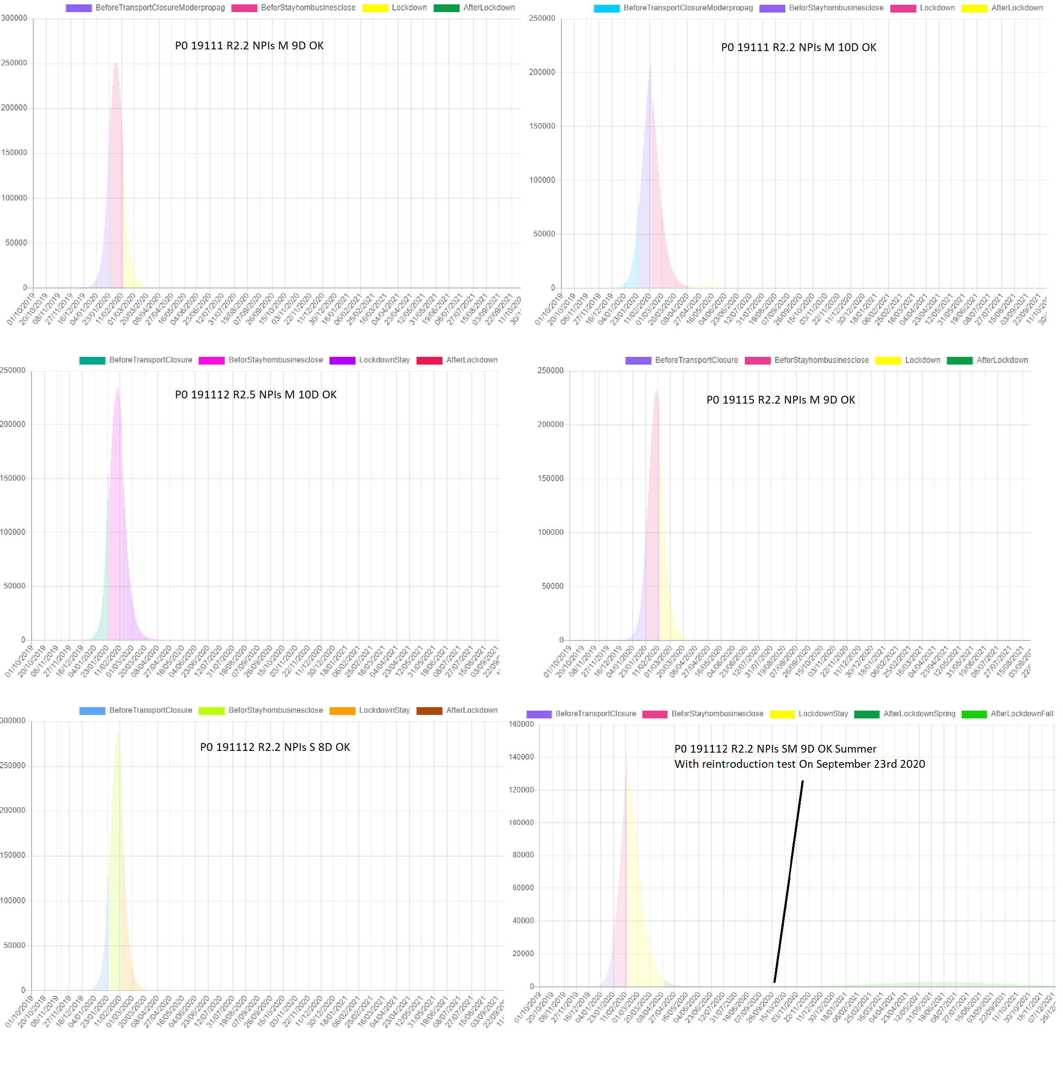

Table 1 scenarios show collective protection after natural course. Factoring changes in propagation based on seasonality[19][20], scenario « P0191112 R2,2 NPIs SM 9D OK Summer » would reach sufficient collective immunity to cause extinction in summer before arrival of fall but could still present a small vulnerability in case of re-introduction in fall as illustrated in figure 1.

Scenario where virus is still present without sufficient collective immunity leads to a rebound as observed in many regions, such as Madrid, New York…. Figure 2

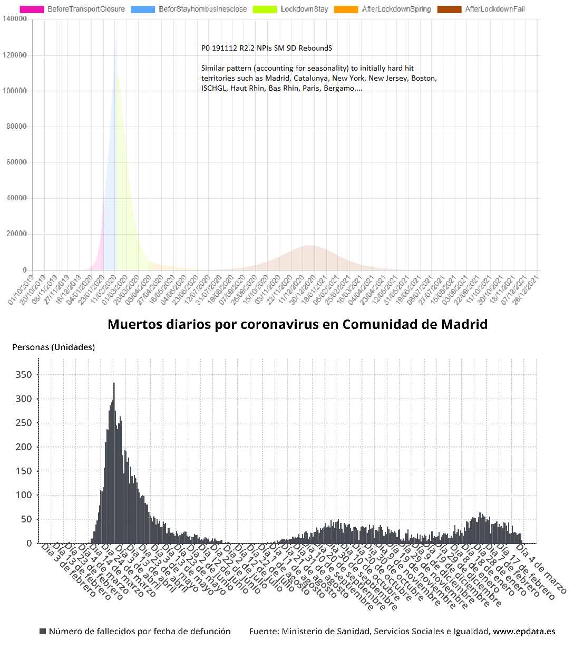

This pattern described in table 2, is visible in many hard-hit territories initially that are having a much milder epidemic course nearing extinction or low circulation depending on immunity strength. This is happening in spite of variants in circulation and infections happening nearly a year before.

Scenarios in which the virus had some of its natural course before being slowed down lead to a rebound at the times where seasonality is most favorable to the epidemic with a comparable rebound as observed in Belgium – Figure 3

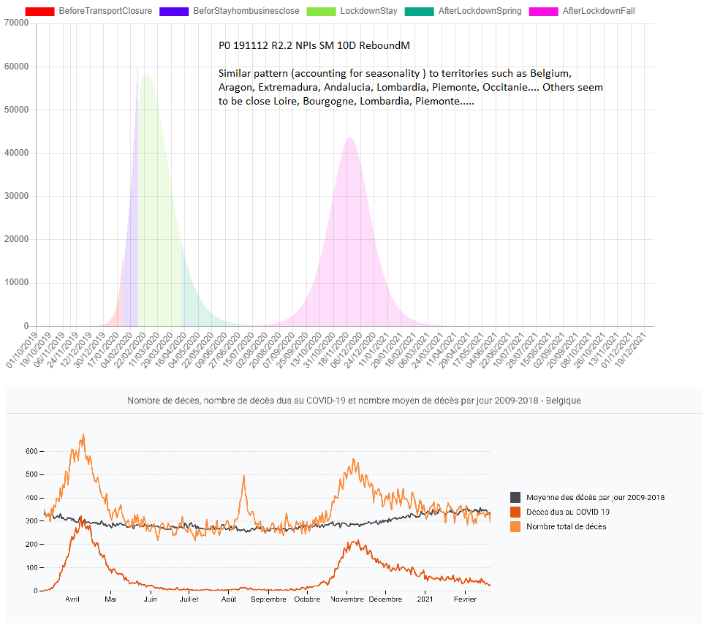

This pattern described in table 2 is consistent with hard hit regions like Belgium which may have completed their epidemic course in Fall 2020 and are not experiencing rebounds for many weeks, despite variants circulating and a rebounding epidemic in Northern France and Netherlands, both of which are experiencing rebounds as the epidemic continues its natural course there.

Scenarios in which the epidemic had been interrupted early in its course saw a much larger second rebound would have happened as observed in Slovenia or Portugal when the season was most appropriate for virus circulation – Figure 4

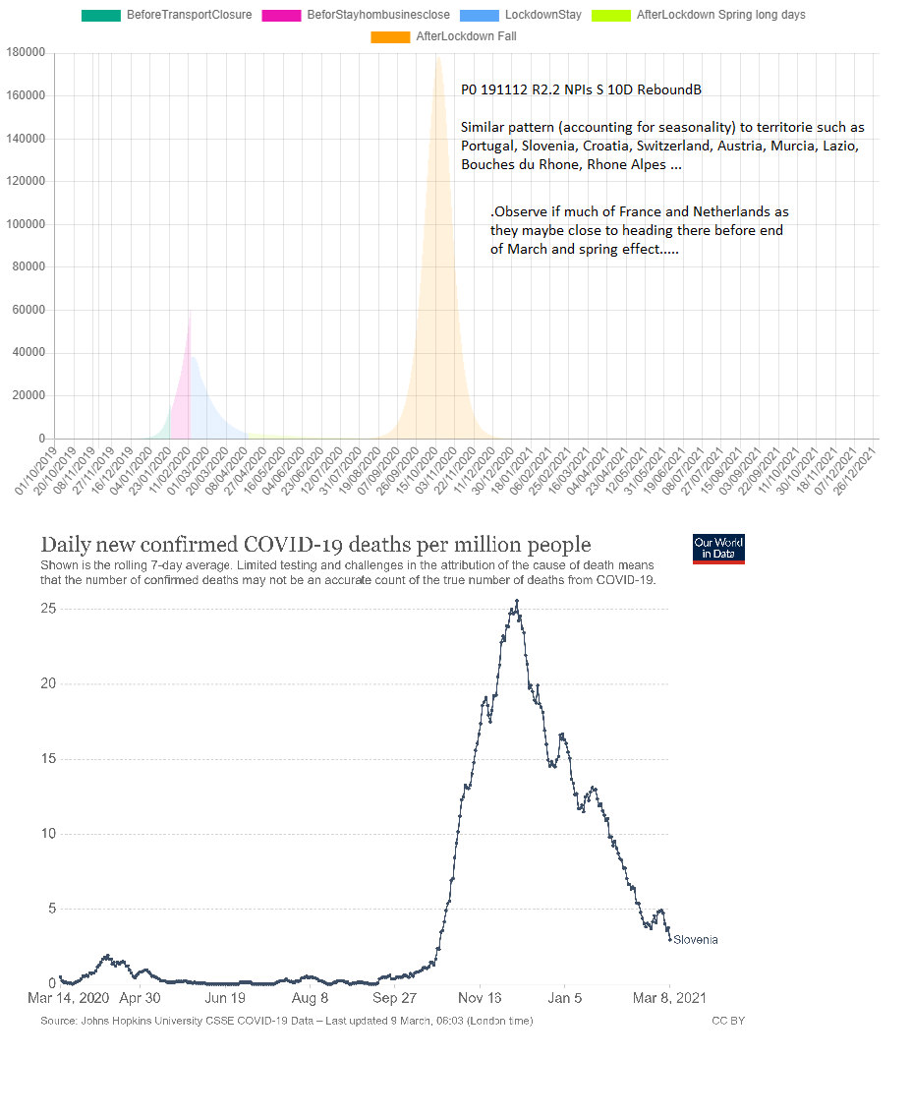

The pattern described in Table 2 is consistent with territories where the epidemic started late enough to be slowed down by spring and summer and covered little of its natural course. If the turnaround happened before spring, it could be hypothesized that the epidemic had much of its natural course and benefits of protection depending on immunity strength.

In temperate zones, the epidemic seemed more aggressive in fall and winter and slowed as spring progressed. The epidemic slowed in Europe in a south to north gradient as spring arrived independently of different NPIs, and then picked up again at fall arrived

Figure 5

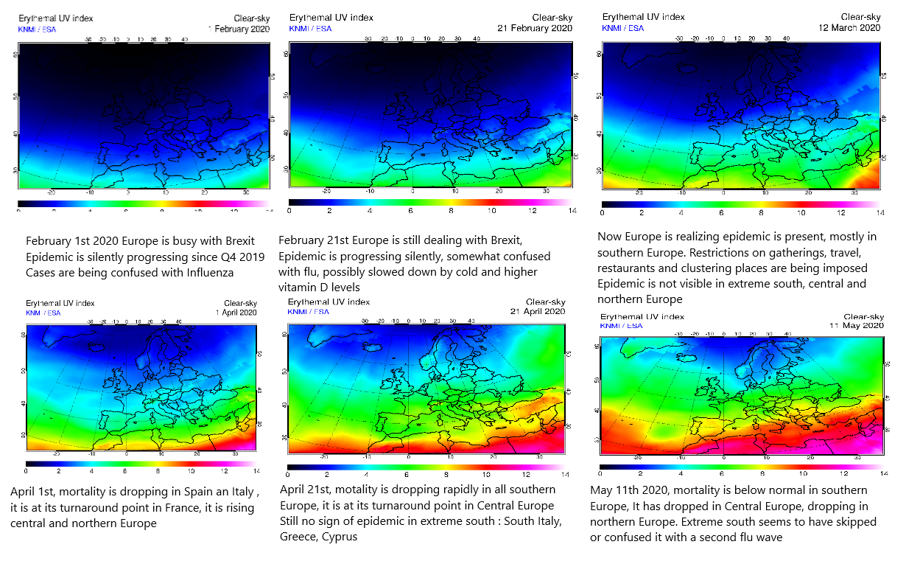This pattern differed in the subtropics where differences in the epidemic aggressivity seemed less marked as we approach the equator as if related to daylight hours.

Comparing US States shows how the epidemic bounced back based on seasonality until sufficient immunity was reached independently of NPIs or variants –

Figure 6

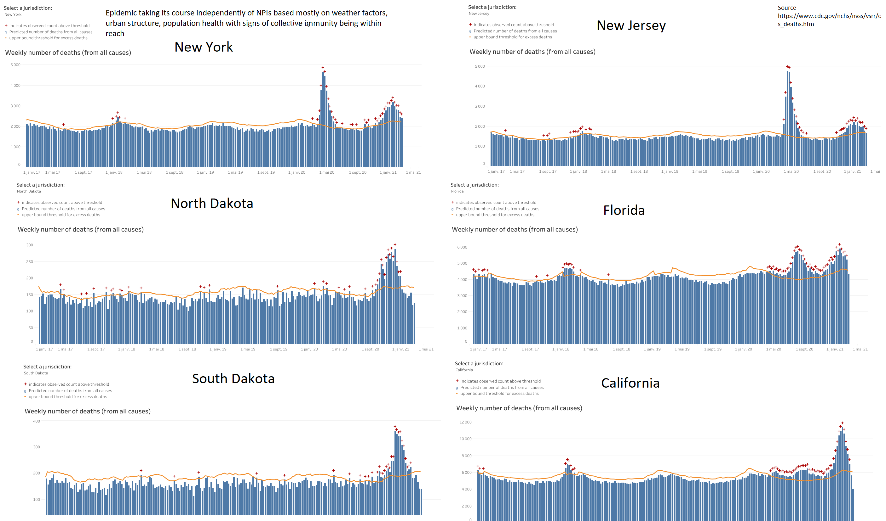

Similarly for French departments - Figure 7



Seasonality trend – Northern Hemisphere countries tempered or mixed seasons Table 3

|  |  |  |  |  |  |  |  |  |  |  |  |  |
| --- | --- | --- | --- | --- | --- | --- | --- | --- | --- | --- | --- | --- |
| Tempered or mixed | Jan | Feb | Mar | Apr | May | Jun | Jul | Aug | Sept | Oct | Nov | Dec |
| Italy |  |  | 1 |  |  |  |  |  |  |  | 1 |  |
| France |  |  | 1 |  |  |  |  |  |  | 1 |  |  |
| Germany | 1 |  | 1 |  |  |  |  |  |  |  |  |  |
| UK |  |  | 1 |  |  |  |  |  |  |  |  | 1 |
| Denmark |  |  | 1 |  |  |  |  |  |  |  |  | 1 |
| Norway |  |  | 1 |  |  |  |  |  |  |  |  | 1 |
| Sweden |  |  | 1 |  |  |  |  |  |  |  |  | 1 |
| Slovenia |  |  | 1 |  |  |  |  |  |  |  | 1 |  |
| Poland |  |  |  | 1 |  |  |  |  |  |  | 1 |  |
| Belgium |  |  | 1 |  |  |  |  |  |  | 1 |  |  |
| Netherlands |  |  | 1 |  |  |  |  |  |  | 1 |  | 1 |
| Ireland | 1 |  |  | 1 |  |  |  |  |  |  |  |  |
| New York |  |  | 1 |  |  |  |  |  |  |  |  | 1 |
| New Jersey | 1 |  | 1 |  |  |  |  |  |  |  |  |  |
| Massachussets |  |  | 1 |  |  |  |  |  |  |  |  | 1 |
| Washington |  |  | 1 |  |  |  |  |  |  |  |  | 1 |
| Pennsylvania |  |  | 1 |  |  |  |  |  |  |  |  | 1 |
| North Dakota |  |  |  |  |  |  |  |  |  |  | 1 |  |
| South Dakota |  |  |  |  |  |  |  |  |  |  | 1 |  |
| Idaho |  |  |  |  |  |  |  |  |  |  | 1 |  |
| Japan | 1 |  |  | 1 |  |  |  |  |  |  |  |  |
| South Korea |  |  | 1 |  |  |  |  |  |  |  |  | 1 |
| Wuhan | 1 |  |  |  |  |  |  |  |  |  |  |  |
| Spain* | 1 |  | 1 |  |  |  |  |  |  | 1 |  |  |
| Portugal* | 1 |  |  |  |  |  |  |  |  |  |  |  |
| Total | 7 | 0 | 17 | 3 | 0 | 0 | 0 | 0 | 0 | 4 | 6 | 10 |
| * Border countries treated as tempered |  |  |  |  |  |  |  |  |  |  |  |  |

Seasonality trend – Northern Hemisphere countries subtropical Table 4

|  |  |  |  |  |  |  |  |  |  |  |  |  |
| --- | --- | --- | --- | --- | --- | --- | --- | --- | --- | --- | --- | --- |
| Subtropical | Jan | Feb | Mar | Apr | May | Jun | Jul | Aug | Sept | Oct | Nov | Dec |
| Israel | 1 |  | 1 |  |  |  |  |  | 1 |  |  |  |
| Jordan |  |  | 1 |  |  |  |  |  |  | 1 |  |  |
| Lebanon | 1 |  |  |  |  |  |  |  |  |  |  |  |
| Morocco |  |  | 1 |  |  |  |  |  |  | 0 | 1 |  |
| Egypt |  |  |  |  | 1 |  |  |  |  |  |  | 1 |
| Tunisia |  |  |  |  |  |  |  |  |  | 1 |  | 1 |
| Algeria |  |  | 1 |  |  |  |  |  |  |  | 1 |  |
| Emirates |  | 1 |  | 1 |  |  |  |  |  |  |  |  |
| Pakistan |  |  |  |  |  | 1 |  |  |  |  |  | 1 |
| Florida | 1 |  |  |  |  |  | 1 |  |  |  |  |  |
| California | 1 |  |  |  |  |  | 1 |  |  |  |  |  |
| Texas | 1 |  |  |  |  |  | 1 |  |  |  |  |  |
| New Mexico |  |  |  | 1 |  |  |  |  |  |  |  | 1 |
| Arizona | 1 |  |  |  |  |  | 1 |  |  |  |  |  |
| Total | 6 | 1 | 4 | 2 | 1 | 1 | 4 | 0 | 1 | 2 | 2 | 4 |

Comparisons of territories and progression towards collective protection subject to seasonality – Figure 8

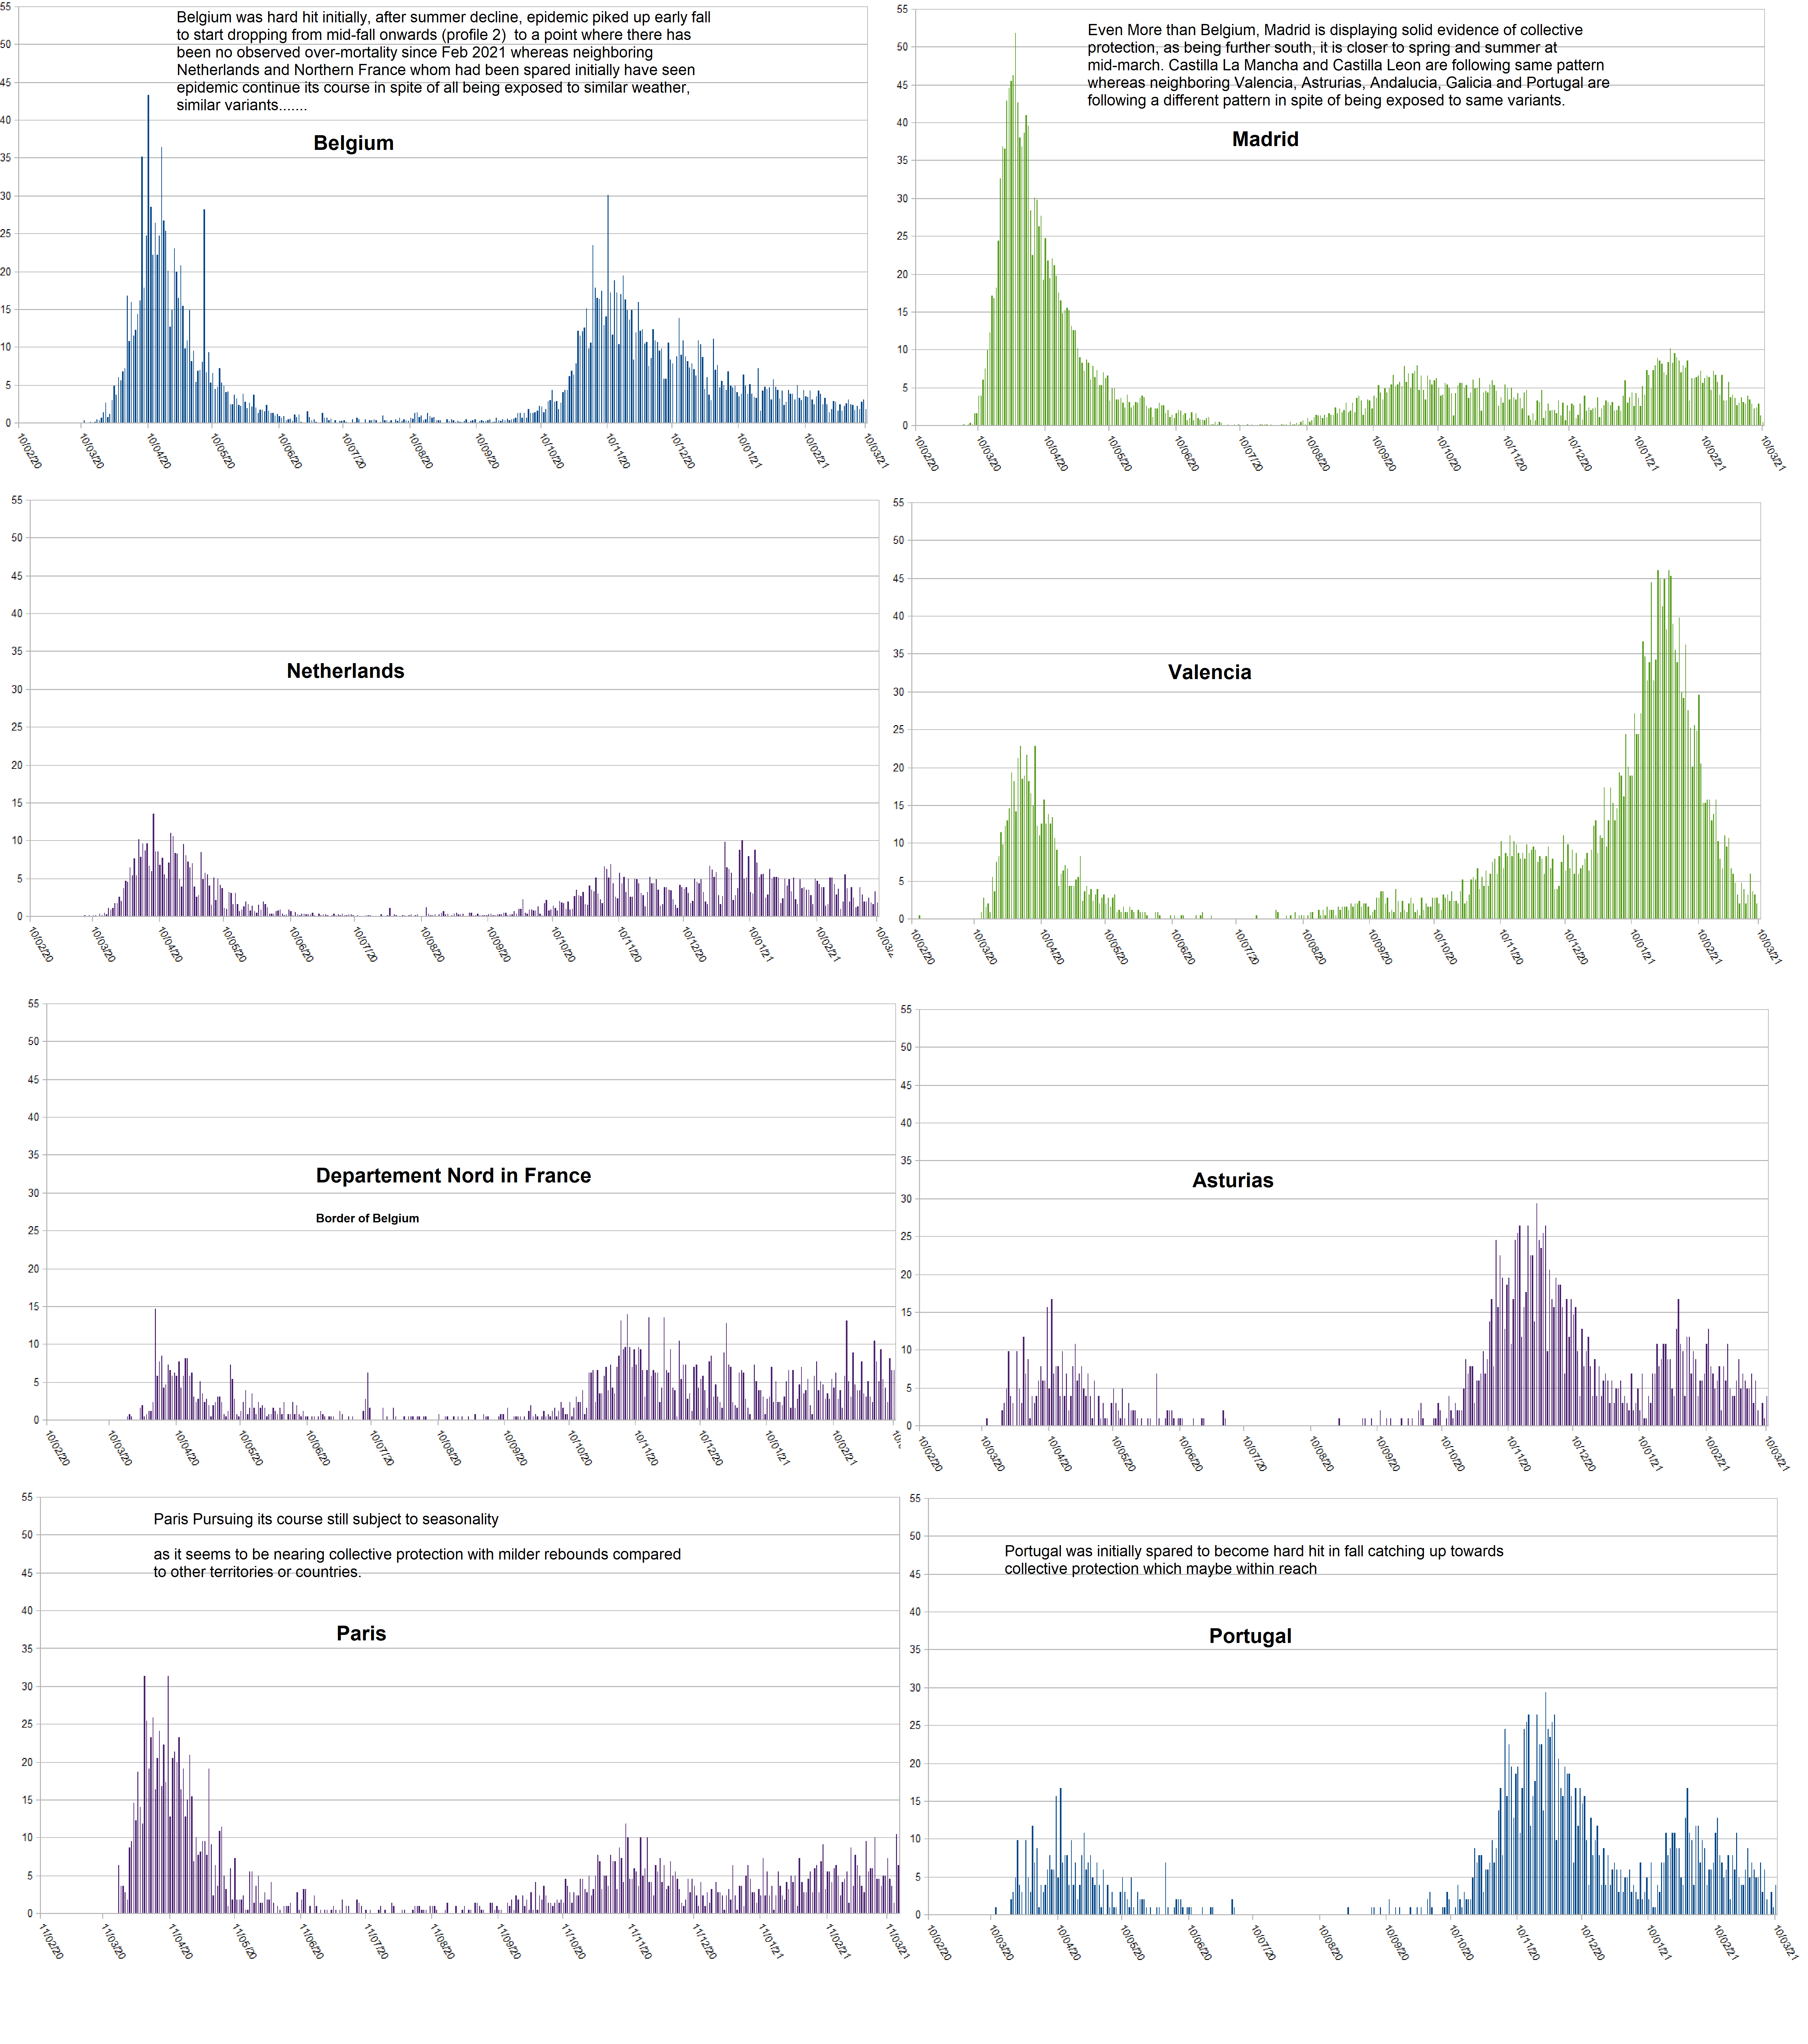

Right skewed curves are indicative of the clustering nature of the epidemic, slowing down progressively after initial infections happened. NPIs may have altered the dissemination factor leading to a more homogeneous spread in some territories with the epidemic inevitably following its course.

Overall, we found a covid mortality trajectory matching that of over-mortality. However, we found in some countries like Sweden, Belgium, or France that covid mortality was significantly higher than excess mortality possibly indicating that, in some countries, mortality was due to comorbidities rather than covid.

Discussion

Some researchers have hypothesized that lockdown and stay home mandate in Wuhan led to virus extermination in the city allowing a return to normal life. No other country or territory in the Northern hemisphere where the virus had reached a significant circulation level succeeded in achieving a similar result. Some countries like Morocco or Israel had very long and strict stay home mandates and failed to exterminate the epidemic sometimes with higher mortality, multiple phases, and longer epidemics than neighboring countries.

Given that:

1) The epidemic had been progressing since mid-November, possibly 3 months before the stay home was mandated and non-essential businesses closed

2) The epidemic was progressing completely freely in the density of Wuhan for more than 2 months without any NPIs

3) The virus was still present and circulating[25][26] after restrictions were lifted from Wuhan without causing visible severe disease or mortality

4) There was no rebound despite a return to normal, including large gatherings through summer, fall and winter. Any rebound in Wuhan would have been visible given the level of international scrutiny by local authorities and international surveillance[41]

The epidemic had probably finished its natural course in Wuhan with enough collective immunity acquired to run out of susceptible people and become harmless by summer 2020 (see Figure 1). This provides a better explanation than that of extermination.

Other territories trying to exterminate the virus through tough NPIs experienced some rebound as in figures 2, 3 and 4.

In tempered territories, although some NPIs may have slowed the epidemic or limited its spread to some territories, the epidemic slowed down significantly with spring and summer and picked-up again mid-fall [table 3]

Many initially hard hit territories like Madrid, Catalunya, Castilla La Mancha, Castilla Leon, Ischgl, Haut Rhin, Bas Rhin, New York, New Jersey, Lombardy or Paris have experienced a milder epidemic through September 2020 till March 2021 at a time in which neighboring territories were experiencing relatively more severe phases. Others like Belgium, Lyon, and Marseille had 2 comparable phases and are no longer displaying signs of excess mortality. Belgium has had no excess mortality since January 2021 in spite to being exposed to the same variants as neighboring countries (see Figures 3 and 8).

Territories like Portugal, Slovenia or Valencia had most of their epidemic in the fall of 2020 and winter 2020/2021 and are no longer displaying signs of excess mortality. This is happening despite being exposed to the same virus variants, similar weather conditions, and independently of NPIs. This is best explained as happened in Wuhan by collective natural immunity, cross immunity, and thus reduction of susceptible population. Severe epidemics happening in places late 2020 and early 2021 such as Portugal, Slovenia, Valencia, Nice, and California despite strict NPIs demonstrates the limited effect of NPIs. Epidemics subsiding in Madrid, Sweden, Florida, Belgium, and South Dakota, despite limited NPIs further hints as to a possible collective protection and the epidemic having followed its natural course.

This would suggest that much of Europe and North America may have within reach sufficient levels of natural collective immunity to prevent new overwhelming episodes. An exception would be Manaus, Brazil, which was hard hit in a second wave in spite of displaying (55)%[33] antibodies in August 2020, further confirming the complexity of the immune system and antibodies test analysis alone as a tool to measure progress toward collective immunity.

Madrid, Spain in May, 2020, had 10% to 14 %[37] positive serology; Ischgl, Austria, in November 2020 had 43% positive serology[28], and Bergamo, Italy in May, 2020 had 38.5% positive serologies.[42] All had a milder second phase. Milder second phases are consistent with the limited number of documented severe re-infections. Population susceptibility, cross immunity, cellular immunity interact in complex ways. Ischgl study shows us how significant cellular immunity may be in duration and ability to react to different strains[43][28]

Summer 2020 vacation and mixing may have contributed to increasing or strengthening such immunity at a favorable time where sunshine may be weakening virus strains and/or strengthening hosts. Many northern hemisphere territories are exhibiting patterns consistent with collective immunity and have been exhibiting such patterns for multiple weeks at times where neighboring territories were still struggling with the epidemic. This protection seems to operate despite new strains circulating. This hints that such territories as well as many other territories that saw epidemic progressing in winter 2020/2021 may have reached some level of collective protection or have it within reach.

Limits

Immunity duration and strength is still unknown and calls for close monitoring. Detailed studies on cross cellular immunity between variants are needed. Studies on what proportions of a population are susceptible are needed. The effects of vaccination cannot yet be foreseen on short or longer terms. The effects of multiple vaccines coexisting cannot be foreseen. The effects of pressure selection applied by massive worldwide simultaneous vaccination cannot be foreseen. Population has become more fragile physiologically and psychologically making it difficult to predict.

The severity of the epidemic varies from one territory to another depending on multiple factors some of which are known such as population health, obesity, population age, urbanism, construction, social structure, susceptibility, density, and available pharmaceutical and medical interventions. Progress towards herd immunity can be analyzed as done in this paper through relative phases comparisons across seasons. A rural territory, with young healthy population living outside would have a very mild epidemic.

Conclusion

Collective immunity explains best Wuhan’s epidemic and its extinction. Seasonality and to a lesser extent NPIs explain why all other territories failed to reach such extinction quickly.

Many northern hemisphere territories may have reached collective natural immunity or have it within reach. Collective immunity, and seasonality have been the main epidemic drivers, which does not exclude some marginal effect of weather, variants, social structure or NPIs contributing to flattening or aggravating “the curve.”

We collectively misread the data, mystified ourselves, invoked stay home mandates despite these NPIs not appearing to end the epidemic in Wuhan or anywhere else as did the natural course and developing immunity. As a result of that and given the damage inflicted on population health and the economy we should consider.

1) All policies should be targeted as to avoid inflicting further damage to populations, extending the epidemic, and thus endangering acquired immunity.

2) Actions should be evidence-based, providing more benefit than harm on the short and the long term.

3) Pressure-selection should be monitored to avoid NPIs and pharmaceutical interventions selecting harmful strains.

4) Given the differences in mortality accounting methods, differences between covid deaths and excess mortality in some countries, lack of clear clinical guidance as to diagnosis and death attribution to avoid risk of an illusion of a continued epidemic even after people have become immune and treatments have become available. PCR tests alone may lead to false positives, mis-allocations, and artificially extending the epidemic.

4) We need careful monitoring possibly through polls and/or wastewater.

5) Independent government comparative studies of treatments, vaccines, or vitamin D as a matter of public health.

6) Urbanism and aeration of dense cities studies as a matter of public health.

7) Protection of populations that need it most through all available tools such as treatments, immunization when appropriate, and possibly vitamin D.

We do not want to appear to oppose masking. It does prevent droplet spray when people are coughing or sneezing. However, widespread community masking may not be as effective as supposed. Perski conducted a meta-analysis among community-dwelling children and adults of studies that assessed the effectiveness of face mask wearing (vs. no face masks) on self-reported, laboratory-confirmed, or clinically diagnosed viral respiratory infections. Among 11 RCTs and 10 observational studies that met their inclusion criteria, they found a moderate likelihood of a small effect of wearing surgical face masks in community settings in reducing self-reported influenza-like illness. They concluded that evidence from RCTs is equivocal as to whether wearing face masks in community settings results in a reduction in clinically- or laboratory-confirmed viral respiratory infections [56]. What we think is important, is that focusing on interventions with small effect sizes may distract us from interventions that could have larger effect sizes. These could include administration of vitamin D, immune-boosting strategies, innovative therapies such as vitamin C, reduction of obesity, and perhaps most importantly, the avoidance of crowding in poorly ventilated areas, which could include an improvement in public and private ventilation for public spaces. Large-scale testing, contact tracing, and targeted quarantining may be more effective than massive lockdowns. All these questions need to be more extensively studied.

Conflict of Interest: The authors have no conflict of interests to report.

Funding statement: The authors received no external funding for this project.

Consent statement/Ethical approval: Not required.

References

[1] Huang C, Wang Y, Li X, et al. (2020)

Clinical Features of Patients Infected With 2019 Novel Coronavirus in Wuhan, China.

The Lancet 395: 497–506.

https://doi.org/10.1016/S0140-6736(20)30183-5

[2] Xingguang Li, Junjie Zai, Xiaomei Wang, Yi Li

Potential of large “first generation” human‐to‐human transmission of 2019‐nCoV

Journal of Medical virology 2020

doi.org/10.1002/jmv.25693

[3] Elizabeth Benedict Kpozehouen, Xin Chen, Mengyao Zhu2, C Raina MacintyreUsing

Open-Source Intelligence to Detect Early Signals of COVID-19 in China: Descriptive Study

JMIR publications 2020

doi:10.2196/18939

[4] Zaheer Allam,

Chapter 1 - The First 50 days of COVID-19: A Detailed Chronological Timeline and Extensive Review of Literature Documenting the Pandemic,

Elsevier, 2020,

Pages 1-7,

ISBN 9780128243138,

https://doi.org/10.1016/B978-0-12-824313-8.00001-2.

[5] Hale T. The First COVID-19 Case Was Earlier Than Initially Thought, Suggests New Report. IFLScience. 2020 Mar 17.

URL: https://www.iflscience.com/health-and-medicine/the-first-covid19-case-was-earlier-than-intially-thought-suggests-new-report/ [accessed 2021-03-18]

[6] Josephine MA Coronavirus: China’s first confirmed Covid-19 case traced back to November 17. South China Morning post 2020 Mar 13

https://www.scmp.com/news/china/society/article/3074991/coronavirus-chinas-first-confirmed-covid-19-case-traced-back / [accessed 2021-03-18]

[7] Andrew A Sayampanathan,Cheryl S Heng, Phua Hwee Pin, Junxiong Pang, Teoh Yee Leong, Vernon J Lee

Infectivity of asymptomatic versus symptomatic COVID-19

Lancet, December 2020

https://doi.org/10.1016/S0140-6736(20)32651-9

[8] Muge Cevik, MRCP, Matthew Tate, MRCP, Ollie Lloyd, MRCP, Alberto Enrico Maraolo, MD, Jenna Schafers, MRCP, Antonia Ho, PhD

SARS-CoV-2, SARS-CoV, and MERS-CoV viral load dynamics, duration of viral shedding, and infectiousness: a systematic review and meta-analysis

Open AccessPublished:November 19, 2020

<https://doi.org/10.1016/S2666-5247(20)30172-5>

[9] Backer Jantien A, Klinkenberg Don, Wallinga Jacco. Incubation period of 2019 novel coronavirus (2019-nCoV)

infections among travellers from Wuhan, China, 20–28 January 2020.

Euro Surveill. 2020;25(5):pii=2000062.

<https://doi.org/10.2807/1560-7917>

[10] Backer Jantien A, Klinkenberg Don, Wallinga Jacco. Incubation period of 2019 novel coronavirus (2019-nCoV)

infections among travellers from Wuhan, China, 20–28 January 2020.

Euro Surveill. 2020;25(5):pii=2000062.

<https://doi.org/10.2807/1560-7917.ES.2020.25.5.2000062>

[11] Faes, C.; Abrams, S.; Van Beckhoven, D.; Meyfroidt, G.; Vlieghe, E.; Hens, N.; Belgian Collaborative Group on COVID-19 Hospital Surveillance.

Time between Symptom Onset, Hospitalisation and Recovery or Death: Statistical Analysis of Belgian COVID-19 Patients. Int. J. Environ. Res. Public Health 2020, 17, 7560.

<https://doi.org/10.3390/ijerph17207560>

[12] Li, Y., Wang, LW., Peng, ZH. et al.

Basic reproduction number and predicted trends of coronavirus disease 2019 epidemic in the mainland of China.

Infect Dis Poverty 9, 94 (2020).

<https://doi.org/10.1186/s40249-020-00704-4>

[13] Bootan Rahman, Evar Sadraddin, Annamaria Porreca

The basic reproduction number of SARS‐CoV‐2 in Wuhan is about to die out, how about the rest of the World?

Wiley online library May 2020

<https://doi.org/10.1002/rmv.2111>

[14] Salzberger, B., Buder, F., Lampl, B. et al.

Epidemiologie von SARS-CoV-2-Infektion und COVID-19.

Internist 61, 782–788 (2020).

<https://doi.org/10.1007/s00108-020-00834-9>

[15] Y Wang, X Y You, Y J Wang, L P Peng, Z C Du, S Gilmour, D Yoneoka, J Gu, C Hao, Y T Hao, J H Li

Estimating the basic reproduction number of COVID-19 in Wuhan

Chinese Journal of Epidemiology, 2020

DOI: 10.3760/cma.j.cn112338-20200210-00086

[16] O’Driscoll, M., Ribeiro Dos Santos, G., Wang, L. et al.

Age-specific mortality and immunity patterns of SARS-CoV-2.

Nature 590, 140–145 (2021).

https://doi.org/10.1038/s41586-020-2918-0

[17] John P A Ioannidis

Infection fatality rate of COVID-19 inferred from seroprevalence data

World Health Organization Bulletin September 2020

<https://doi.org/10.1101/2020.05.13.20101253>

[18] Eran Bendavid Christopher Oh Jay Bhattacharya John P. A. Ioannidis

Assessing mandatory stay‐at‐home and business closure effects on the spread of COVID19

European Journal of clinical investigation January 2021

https://doi.org/10.1111/eci.13484

[19] Quentin De Larochelambert, Andy Marc, Juliana Antero, Eric Le Bourg and Jean-François Toussaint

Covid-19 Mortality: A Matter of Vulnerability Among Nations Facing Limited Margins of Adaptation

Front. Public Health, 19 November 2020

https://doi.org/10.3389/fpubh.2020.604339

[20] Seasonality and Progression of COVID-19 among Countries With or Without Lock-downs.

Dr. Jose-Luis Sagripanti

medrxiv December 2020

https://doi.org/10.1101/2020.12.06.20244780

[21] J. Krywyk, W. Oettgen, M. Messier, M. Mulot, A. Ugon, L. Toubiana

Dynamics of the covid19 pandemics : Global patterns and between countries variations

Researchgate July 2020

https://doi.org/10.1101/2020.07.20.20155390

[22] Lewis Mehl-Madrona, François Bricaire, Adrian Cuyugan, Jovan Barac, Asadullah Parvaiz, Ali Bin Jamil, Sajid Iqbal, Ryan Vally, Meryem Koliali, Mohamed Karim Sellier,

Understanding SARSCOV-2 propagation, impacting factors to derive possible scenarios and simulations

Medrxiv September 2020

https://doi.org/10.1101/2020.09.07.20190066

[23] Rabail Chaudhry,George Dranitsaris, Talha Mubashir, Justyna Bartoszko, Sheila Riazi

A country level analysis measuring the impact of government actions, country preparedness and socioeconomic factors on COVID-19 mortality and related health outcomes

Eclinical medecine VOLUME 25, 100464, AUGUST 01, 2020

https://doi.org/10.1016/j.eclinm.2020.100464

[24] Haug, N., Geyrhofer, L., Londei, A. et al.

Ranking the effectiveness of worldwide COVID-19 government interventions.

Nat Hum Behav 4, 1303–1312 (2020).

<https://doi.org/10.1038/s41562-020-01009-0>

[25] Cao, S., Gan, Y., Wang, C. et al.

Post-lockdown SARS-CoV-2 nucleic acid screening in nearly ten million residents of Wuhan, China.

Nat Commun 11, 5917 (2020).

https://doi.org/10.1038/s41467-020-19802-w

[26] Shuhui Duan,Meiying Zhou,Wen Zhang,Jianwei Shen,Rui Qi,Xiangrong Qin,Hao Yu,Chuanmin Zhou,Qing Hu ,Xue-Jie Yu

Seroprevalence and asymptomatic carrier status of SARS-CoV-2 in Wuhan City and other places of China

PLOS Neglected Tropical diseases January 7, 2021

<https://doi.org/10.1371/journal.pntd.0008975>

[27] Gilles Pison, France Meslé

68 000 excess deaths attributed to Covid

Ined March 2021

<https://www.ined.fr/fichier/s_rubrique/31218/587.excess.deaths.covid.19.march.2021.en.pdf>

(accessed March 20th 2021)

[28] Wegene Borena, Zoltán Bánki, Katie Bates, Hannes Winner, Lydia Riepler, Annika Rössler, Lisa Pipperger, Igor Theurl, Barbara Falkensammer, Hanno Ulmer, Andreas Walser, Daniel Pichler, Matthias Baumgartner, Sebastian Schönherr, Lukas Forer, Ludwig Knabl, Reinhard Würzner, Dorothee von Laer, Jörg Paetzold, Janine Kimpel

Follow-up study in the ski-resort Ischgl: Antibody and T cell responses to SARS-CoV-2 persisted for up to 8 months after infection and transmission of virus was low even during the second infection wave in Austria

Medrxiv February 2021

<https://doi.org/10.1101/2021.02.19.21252089>

[29] JOSE MATEUS, ALBA GRIFONI, DANIELA WEISKOPF et al

Selective and cross-reactive SARS-CoV-2 T cell epitopes in unexposed humans, Preexisting immunity against SARS-CoV-2 can be derived from coronaviruses that cause the common cold.

SCIENCE02 OCT 2020 : 89-94

DOI: 10.1126/science.abd3871

[30] Lipsitch, M., Grad, Y.H., Sette, A. et al.

Cross-reactive memory T cells and herd immunity to SARS-CoV-2.

Nat Rev Immunol 20, 709–713 (2020).

https://doi.org/10.1038/s41577-020-00460-4

[31] Huibin Lv, Nicholas C. Wu, Owen Tak-Yin Tsang, Chris K.P. Mok et al

Cross-reactive Antibody Response between SARS-CoV-2 and SARS-CoV Infections

Cell reports 2020

https://doi.org/10.1016/j.celrep.2020.107725

[32] Marta Ferreira-Gomes, Andrey Kruglov,Mir-Farzin Mashreghi et al

In severe COVID-19, SARS-CoV-2 induces a chronic, TGF-β-dominated adaptive immune response

medrxiv september 2020

https://doi.org/10.1101/2020.09.04.20188169

[33] Ester C Sabino, Nuno R Faria et al

Resurgence of COVID-19 in Manaus, Brazil, despite high seroprevalence

Lancet January 2021

<https://doi.org/10.1016/S0140-6736>

[34] Alrubayyi, A.

B cell persistence and evolution to SARS-CoV-2.

Nat Rev Immunol 21, 3 (2021).

https://doi.org/10.1038/s41577-020-00481-z

[35] E. Hartley, Emily S.J. Edwards, Menno C. van Zelm

Rapid generation of durable B cell memory to SARS-CoV-2 spike and nucleocapsid proteins in COVID-19 and convalescence

Science immunology December 2020

DOI: 10.1126/sciimmunol.abf8891

[36] Tom Britton, Frank Ball2, Pieter Trapman

A mathematical model reveals the influence of population heterogeneity on herd immunity to SARS-CoV-2

SCIENCE14 AUG 2020 : 846-849

DOI: 10.1126/science.abc6810

[37] Prevalence of SARS-CoV-2 in Spain (ENE-COVID): a nationwide, population-based seroepidemiological study

Marina Pollán, Beatriz Pérez-Gómez, Roberto Pastor-Barriuso, Jesús Oteo, Miguel A Hernán, Mayte Pérez-Olmeda, et al.

Lancet July 2020

DOI:https://doi.org/10.1016/S0140-6736(20)31483-5

[38] Gomes, M. G. M., Corder, R. M., King, J. G., Langwig, K. E., Souto-Maior, C., Carneiro

Aguas, R. (2020). Individual variation in susceptibility or exposure to SARS-CoV-2 lowers

the herd immunity threshold.

medRxiv May 2020

doi:10.1101/2020.04.27.20081893

[39] Lewis, N. (2020, 20 May 2020). Why herd immunity to COVID-19 is reached much earlier than

thought. Retrieved from

https://judithcurry.com/2020/05/10/why-herd-immunity-to-covid19-is-reached-much-earlier-than-thought/ [Accessed March 21st 2021]

[40] Ricardo Aguas, Rodrigo M. Corder, Jessica G. King, Guilherme Gonçalves, Marcelo U. Ferreira, M. Gabriela M. Gomes

Herd immunity thresholds for SARS-CoV-2 estimated from unfolding epidemics

Medrxiv November 2020

doi:10.1101/2020.07.23.20160762

[41] Nsoesie, Elaine Okanyene, Benjamin Rader, Yiyao L. Barnoon, Lauren Goodwin, and John S. Brownstein.

Analysis of hospital traffic and search engine data in Wuhan China indicates early disease activity in the Fall of 2019 (2020).

<https://dash.harvard.edu/handle/1/42669767>

Accessed March 20th 2021

[42] Luca Perico, Susanna Tomasoni, Tobia Peracchi et al.

COVID-19 and lombardy: TESTing the impact of the first wave of the pandemic

E Bio Medicine October 2020

DOI:https://doi.org/10.1016/j.ebiom.2020.103069

[43] Alison Tarke, John Sidney, Nils Methot, Yun Zhang, Alessandro Sette et al.

Negligible impact of SARS-CoV-2 variants on CD4+ and CD8+ T cell reactivity in COVID-19 exposed donors and vaccinees

medrxiv March 2021

doi: https://doi.org/10.1101/2021.02.27.433180

[44] Leen Vijgen, Els Keyaerts, Elien Moës, Inge Thoelen, Elke Wollants, Philippe Lemey, Anne-Mieke Vandamme, and Marc Van Ranst

Complete Genomic Sequence of Human Coronavirus OC43: Molecular Clock Analysis Suggests a Relatively Recent Zoonotic Coronavirus Transmission Event

Journal of virology Jan 2005

<https://dx.doi.org/10.1128%2FJVI.79.3.1595-1604.2005>

[45] <https://www.euromomo.eu/graphs-and-maps/>

Accessed March 20th 2021

[46] <https://www.epdata.es/datos/evolucion-coronavirus-cada-comunidad/518/cataluna/297>

Accessed March 15th 2021

[47] <https://statistichecoronavirus.it/coronavirus-italia/>

Accessed March 15th 2021

[48] <https://www.data.gouv.fr/en/datasets/donnees-hospitalieres-relatives-a-lepidemie-de-covid-19/>

Accessed March 15th 2021

[49] <https://www.coronavirus-statistiques.com/stats-globale/toutes-les-statistiques-coronavirus-covid19/>

Accessed March 15th 2021

[50] <https://www.data.gouv.fr/fr/datasets/donnees-hospitalieres-relatives-a-lepidemie-de-covid-19>

Accessed March 20th 2021

[51] <https://www.insee.fr/fr/statistiques/4487854>

Accessed March 15th 2021

[52] [https://covid-19.sciensano.be/sites/default/files/Covid19/Derni%C3%A8re%20mise%20%C3%A0%20jour%20de%20la%20situation%20%C3%A9pid%C3%A9miologique.pdf](https://covid-19.sciensano.be/sites/default/files/Covid19/Dernière%20mise%20à%20jour%20de%20la%20situation%20épidémiologique.pdf)

Accessed March 15th 2021

[53] <https://statbel.fgov.be/fr/open-data/nombre-de-deces-par-jour-sexe-arrondissement-age>

Accessed March 15th 2021

[54] <https://www.ons.gov.uk/peoplepopulationandcommunity/healthandsocialcare/conditionsanddiseases>

Accessed March 15th 2021

[55] <https://ourworldindata.org/>

Accessed March 15th 2020